**SAP ENABLE SCRIPTING FOR UI PATH**

1. Open SAP - > Klik Menu Options

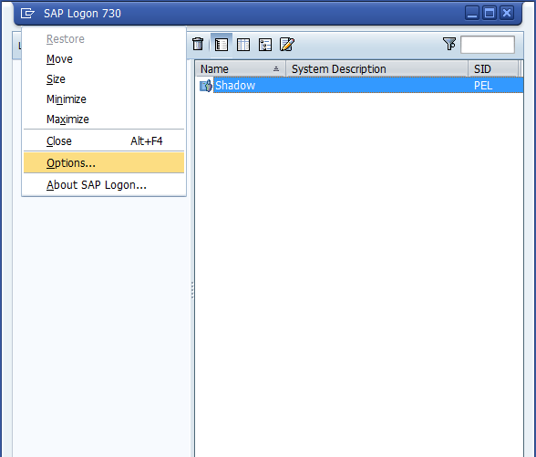

1. Checklist Enable Scripting - > Apply

